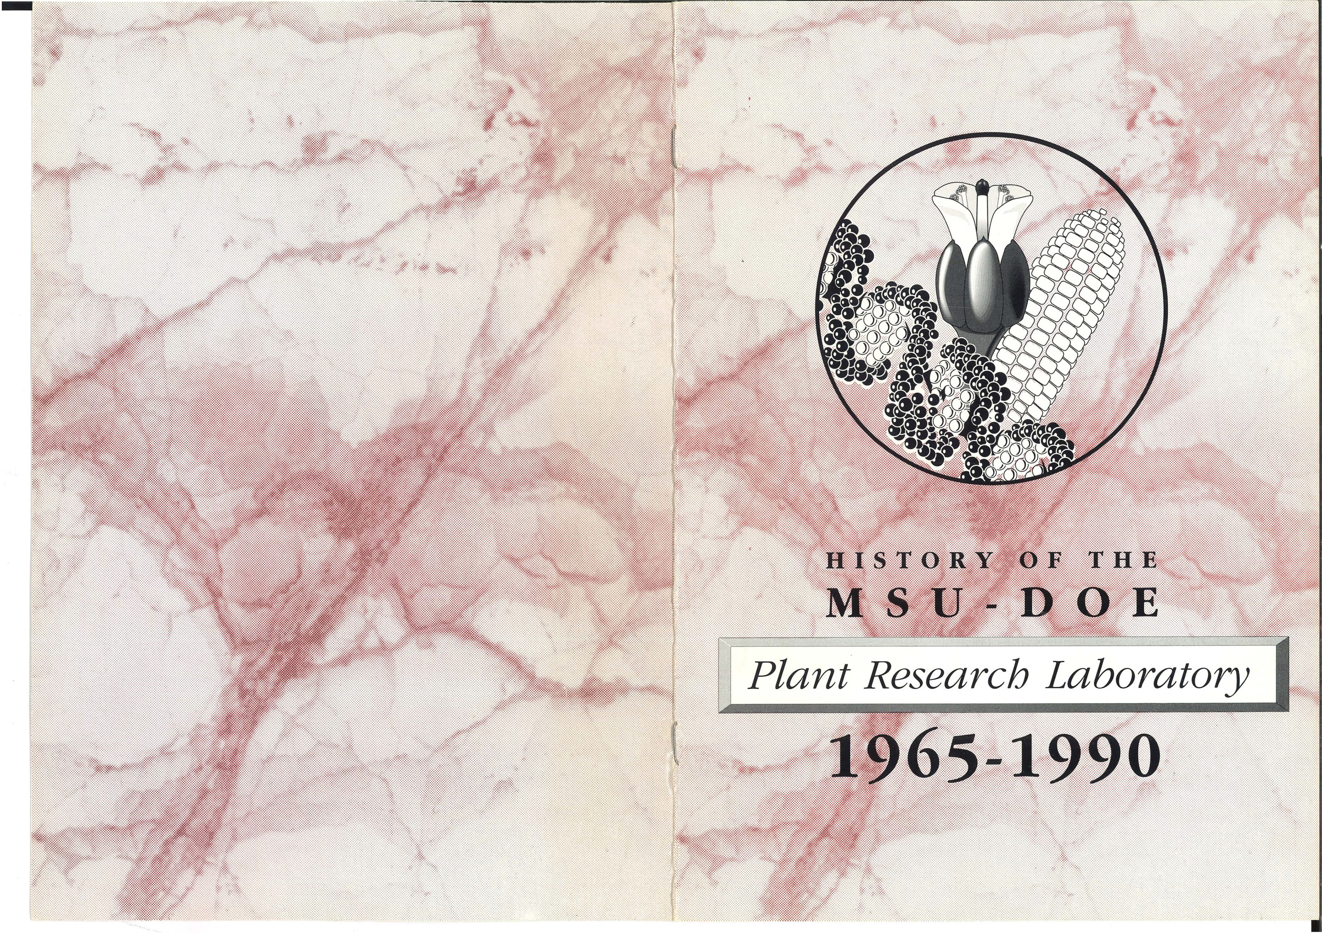

**HISTORY OF THE PLANT RESEARCH LABORATORY**

**The Beginnings Anton Lang**

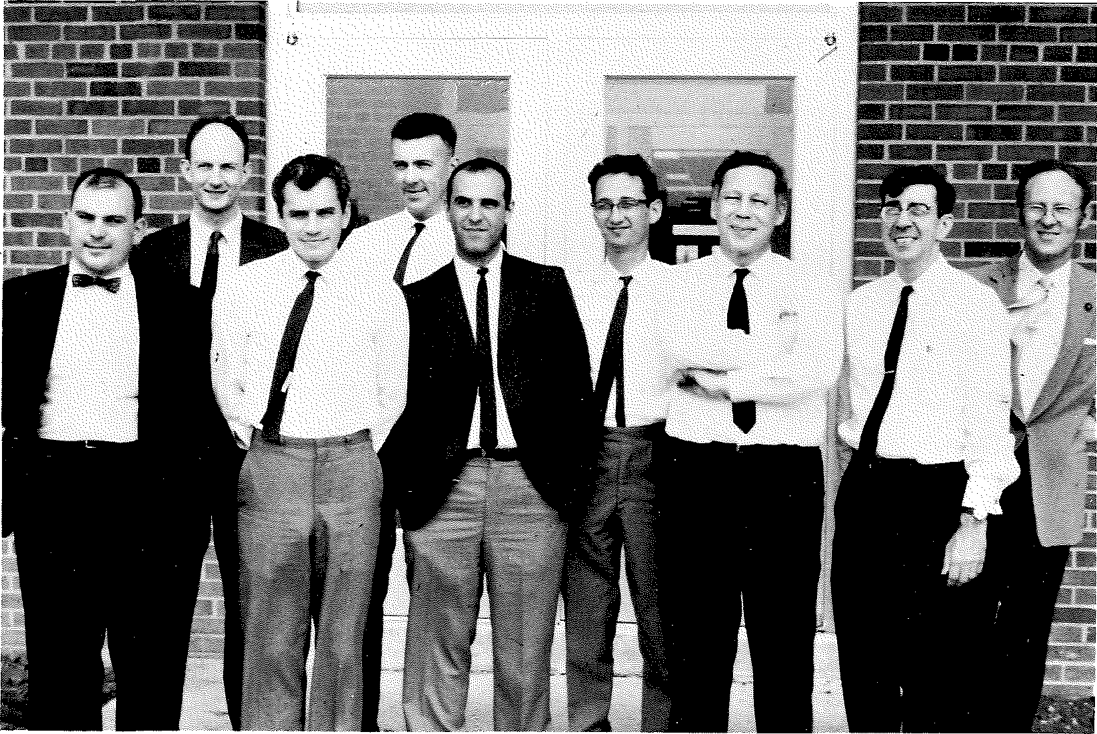Since its inception in the early 1950's, the Division of Biology and Medicine (DBM) of the Atomic Energy Commission had considered research with plants essential to its mIssIon. However, it became clear that the plant research programs of AEC (and elsewhere) were lagging behind those in other scientific areas. In 1959, a select committee of plant biologists was convened to review the plant research programs supported by DBM. It concluded that plant sciences in the United States were not in a healthy state and that the obvious deficiencies noted in DBM's program would be difficult to overcome because they were a reflection of the general situation. The committee recommended that on-site programs, for example at Brookhaven National Laboratory, should be expanded and that a new, broadly based program should be initiated at one or more universities where student interest in plant research could be fostered. A second *ad hoc* committee was convened in the fall of 1961 to deal with the latter recommendation.

In addition to concurring with the finding that a university-based program was needed, the second group also established guidelines for the selection of a university where an interdisciplinary research and training program in the plant sciences could be established by AEC. The committee suggested that the university selected should (a) have a demonstrated interest in plant sciences and radiation biology and a strong graduate program; (b) be closely associated with a land-grant college; (c) not have rigidly established departmental lines which would tend to restrict cooperative projects; (d) be willing to grant academic tenure appointments to senior staff; and several other administrative criteria. The recommendations for establishing a university-based program that would be firmly integrated with the rest of the university and the criteria for its selection were endorsed by the standing Advisory Committee of DBM in the summer of 1962.

The original nine faculty members of the Plant Research Laboratory, June 1966. From left to right: Phil Filner, Peter Wolk, Joe Varner, Jan Zeevaart, John Scandalios, Hans Kende, Anton Lang, Lloyd Wilson, and Derek Lamport.

Staff members of the Division subsequently identified and evaluated 42 universities for their breadth and depth in plant sciences and reduced the number of institutions to fifteen. After further study, four of these - the Universities of Illinois, Minnesota and Wisconsin, and Michigan State University - were selected for site visits. On the basis of these visits, during which extensive discussions were held with faculty members and administrators, Michigan State University was considered to have best met all criteria and was invited to submit a proposal. DBM determined that the proposal by Michigan State University was scientifically sound. The recommendation for initiating a multidisciplinary research and training program in the plant sciences relevant to AEC interests was approved

by the Commissioners of the AEC and later by the Congressional Joint Committee on Atomic Energy. Based on this, the necessary funds were allocated to this program within the AEC budget, and a contract between AEC and the University was signed on March 6, 1964.

This contract provided for a comprehensive research program in plant biology and related education and training at the graduate and postgraduate levels. The program was to draw strongly on related disciplines such as biochemistry, biophysics, genetics, microbiology and others as the need might be determined; it also provided for the construction of a building to house the new facility. Over the past years, other centers for plant research have been created, e.g. the Complex Carbohydrate Center at the University of Georgia, Athens, and the Plant Gene Expression Center of the U.S.D.A. and the University of California-Berkeley at Albany. However, it is important to recognize that AEC was the first agency to take a major step in this direction.

After the signing of the contract, plans for the Laboratory building were developed and its construction started. Lloyd Wilson, Assistant Professor in the Botany and Plant Pathology Department, was placed in charge of administrative work which included supervising the building's construction, hiring of some supporting personnel and purchase of general equipment and supplies. It was thanks to these activities that the PRL's new faculty members could start their research work virtually immediately upon their arrival in East Lansing. I was appointed Director of the PRL on May 1, 1965, and the first seven faculty members as well as the first graduate students and postdoctoral research associates arrived in 1964-65. Many of the students and research associates came with the new faculty members from their previous locations. When I arrived, the PRL Building was still largely a hole in the ground, and the Laboratory was housed in the Biochemistry Building. However, in July, 1966, we were able to move across the street into our own quarters. The full complement of the faculty, 12 apart from the Director, was reached in 1969, with joint appointments in the Departments of Botany and Plant Physiology, Biochemistry, and Biophysics; later appointments were with the Departments of Crop and Soil Sciences and Microbiology and Public Health.

The first PRL Seminar was presented on October 11, 1965 by Klaus Raschke, who somewhat later joined the PRL faculty. In addition to a major weekly seminar series, which mostly features outside speakers, another, more informal series devoted mainly for reports on the Laboratory's own current research, was started later. The first PRL Annual Report appeared in 1967, summarizing research done in 1965-66; the Report has since been published every year to inform interested scientists and institutions of the Laboratory's work.

I have quite often been asked about my "philosophy" in setting up and directing the PRL. The answer may be disappointing since my approach was a very pragmatic one although it obviously had to be based on some guiding ideas. I will not deal here with the mechanics of the directorship - the actual administrative needs and challenges and the representation of the unit vis-a-vis the higher administration and the scientific community. These are similar in any position of this type and rather self-evident. The only somewhat unusual feature in the case of the PRL is that the Director has to keep two administrations, that of MSU and that of the granting agency in Washington (AEC, ERDA, DOE), happy; The unique challenges to any director who is to develop a research unit "from scratch" are to block out a program, find the people to staff it, and provide optimal facilities and environment so the staff can devote full time to research and training. Once this is achieved, the Director has to monitor the performance closely, seeking to improve it further in the face of a rapidly developing and changing field, recognizing accomplishments, but also recognizing and correcting weaknesses and deficiencies in the program.

Regarding the PRL's research program, it would have been futile to try to cover all aspects and areas of experimental plant biology: selection was necessary and was guided by several considerations. One was to have a balance of work on general biological problems, to be conducted with plants, and work on specifically "planty" phenomena. Plants, animals and microorganisms share many common features: the genetic code and how it is read, many properties of cell structure and function, certain aspects of development like the formation of some patterns. On the other hand, both plants and animals have features of their own, with no analogy in the opposite kingdom. It is generally known that only plants (and a few microorganisms) can convert inorganic into organic matter, thus providing the basis for virtually all life on earth (except perhaps some simple microorganisms that have learned to derive the energy needed for their life from inorganic reactions). But there are other striking differences, too. Animals are developmentally "closed" systems; their organs are all laid down early in development, including reproductive organs, none being added later in life. Plants are "open" systems; they keep adding organs,

both identical and novel ones. For example, the reproductive organs (flowers) are initiated quite late in the life of many higher plants. Cells *ot* plants are surrounded by walls and grow mainly by uptake of water into special organelles, the central vacuoles. Plants and animals also differ in some general aspects of hormonal regulation, animals possessing

numerous hormones with mostly highly specialized activities while plants manage with a much smaller set of hormones which, however, participate in the regulation of numerous different processes. Another very important difference between the two types of organisms is their relation to the environment: animals can, at least within limits and temporarily, escape their environment; plants have to cope with theirs "on site." I considered it important that the research program of the PRL reflected these different aspects of plant biology. Of the first projects, or in AEC term ''tasks", that were created, some focused on

problems specific to plants, such as cell growth and its regulation by plant hormones, cell wall structure and composition, and the physiology of flower formation; others addressed general biological problems such as the regulation of enzyme formation during development, and cellular and genetical aspects of hormone action. Of course, this classification of projects was not intended to form rigid dividing lines. On the contrary, most of the projects in one of these categories included elements of the other, and projects in either category included studies on the effects of environmental factors (light, temperature) on the phenomena studied.

Regarding staffing, my prime "philosophy" was to find the right people - based on a firm conviction of mine that progress in basic sciences is made by individuals: persons whose work was already clearly at the cutting edge of their problem area or, in the case of younger scientists, persons showing the promise of attaining this stature. The precise type of problem or problems they were studying was of secondary importance as long as it fitted the overall program of the Laboratory. Three corollaries were: The appointees should be able to convey their own enthusiasm for research to their younger co-workers; there should be some overlap in their research activities to ensure a common language; and they should have a broad, nonpossessive attitude towards research, being willing to share ideas and undertake cooperative work. These characteristics, especially the second and third, were considered essential to make the unit's program more than the mere sum of its component projects or tasks.

By the fall of 1965, the following faculty members had arrived at the PRL: **Phil Filner** (Assistant Professor of Biochemistry) from Caltech; **Hans Kende** (Associate Professor of Botany) from the Negev Institute of Arid Zone Research, Beersheba, Israel; **Derek Lamport** (Research Assistant Professor) from the Research Institute for Advanced Studies (RIAS) in Baltimore; **John Scandalios** (Research Assistant Professor) from the University of Hawaii; **Joe Varner** (Professor of Biochemistry) from RIAS in Baltimore; **Peter Wolk** (Assistant Professor of Botany) from Caltech; and **Jan Zeevaart** (Associate Professor of Botany) from McMaster University in Hamilton, Canada. Later additions or replacements were: in 1966 **Rainer Hertel** (Research Assistant Professor) from the University of Cologne, FRG; in 1967, **Michael Jost** (Assistant Professor of Botany) from Northwestern University; **Alfred Haug** (Associate Professor of Biophysics) from Caltech; **Klaus Raschke** (Professor of Botany) from the University of Giessen, FRG; and in 1974, **Deborah Delmer** (Assistant Professor of Biochemistry) and **Ken Poff** (Assistant Professor of Botany), both from the University of California at San Diego.

Turning now to the monitoring part of the Director's job, I tried, of course, as anyone in such a position would do, to keep closely informed of research progress in each of the Laboratory's tasks. However, for a broader basis and greater objectivity, two mechanisms were introduced early in the existence of the Laboratory. One of these was

the institution of visiting committees which consisted of a number of distinguished members of other universities and institutions with expertise in those disciplines currently represented in the PRL program. These committees came to East Lansing at more or less regular intervals - alternating with similar committees appointed by AEC, ERDA or DOE - spent time with all tasks in the Laboratory and submitted a report evaluating their performance and offering advice and criticism as a form of peer review. The other mechanism were internal reviews to which all faculty members were subjected, junior ones annually, more senior ones at greater intervals, and at which the performance of the faculty member .. was evaluated on the basis of an oral presentation, publication record, and other criteria. The opinion of graduate assistants and research associates were also sought and considered. Parenthetically, it may be mentioned here that quite early in its history, the PRL included a representative each of graduate assistants and research associates in its faculty meetings (which were therefore called Academic Personnel Meetings) and on all standing and ad-hoc committees. This was done before student representation was mandated by the University bylaws and has remained a very positive feature of the PRL "constitution."

How has this "philosophy'' of developing and guiding the PRL worked out? Obviously, this is not for me to judge, but a few comments may be permissible. First, if - perish the thought - I had to do it all over again, some details in the personnel and the mechanics of the Laboratory would be different, but the concepts would be the same. Furthermore, some faculty left while I was still Director and others have done so since, and have been replaced by new appointees. Of the "charter members" of the faculty - those who started their research still in the Biochemistry Building - only four are still on board. Even though we regretted to see our colleagues leave, a steady turnover of faculty is a healthy process which helps to keep the research program lively and allows for the attraction of new talent. Because of the activities of the "new" faculty and of changes in the programs of the "old" tasks, the overall research program of the PRL is quite different from what it was when our first annual report was published. The most striking increase is in work at the molecular level. However, this molecular work is plant-biology-driven, and the PRL's research program as a whole continues to represent a well-balanced and well­ integrated cross-section of modern plant biology. ,,My impression is that the PRL has evolved but has also stayed the same; my wish is that it succeeds in maintaining this balancing act for the next 25 years.

At the end of this sketch, it is only appropriate to recognize those individuals to whom the PRL owes its existence at MSU. On the University's side, the first major factor was the strong commitment by President John Hannah, Vice President Philip May, Agricultural Experiment Station Director Sylvan Wittwer, and the Deans of the Colleges of Natural Science and of Agriculture and Natural Resources, Richard Byerrum and Thomas Cowden, to strengthen plant biology on campus, including construction of the necessary

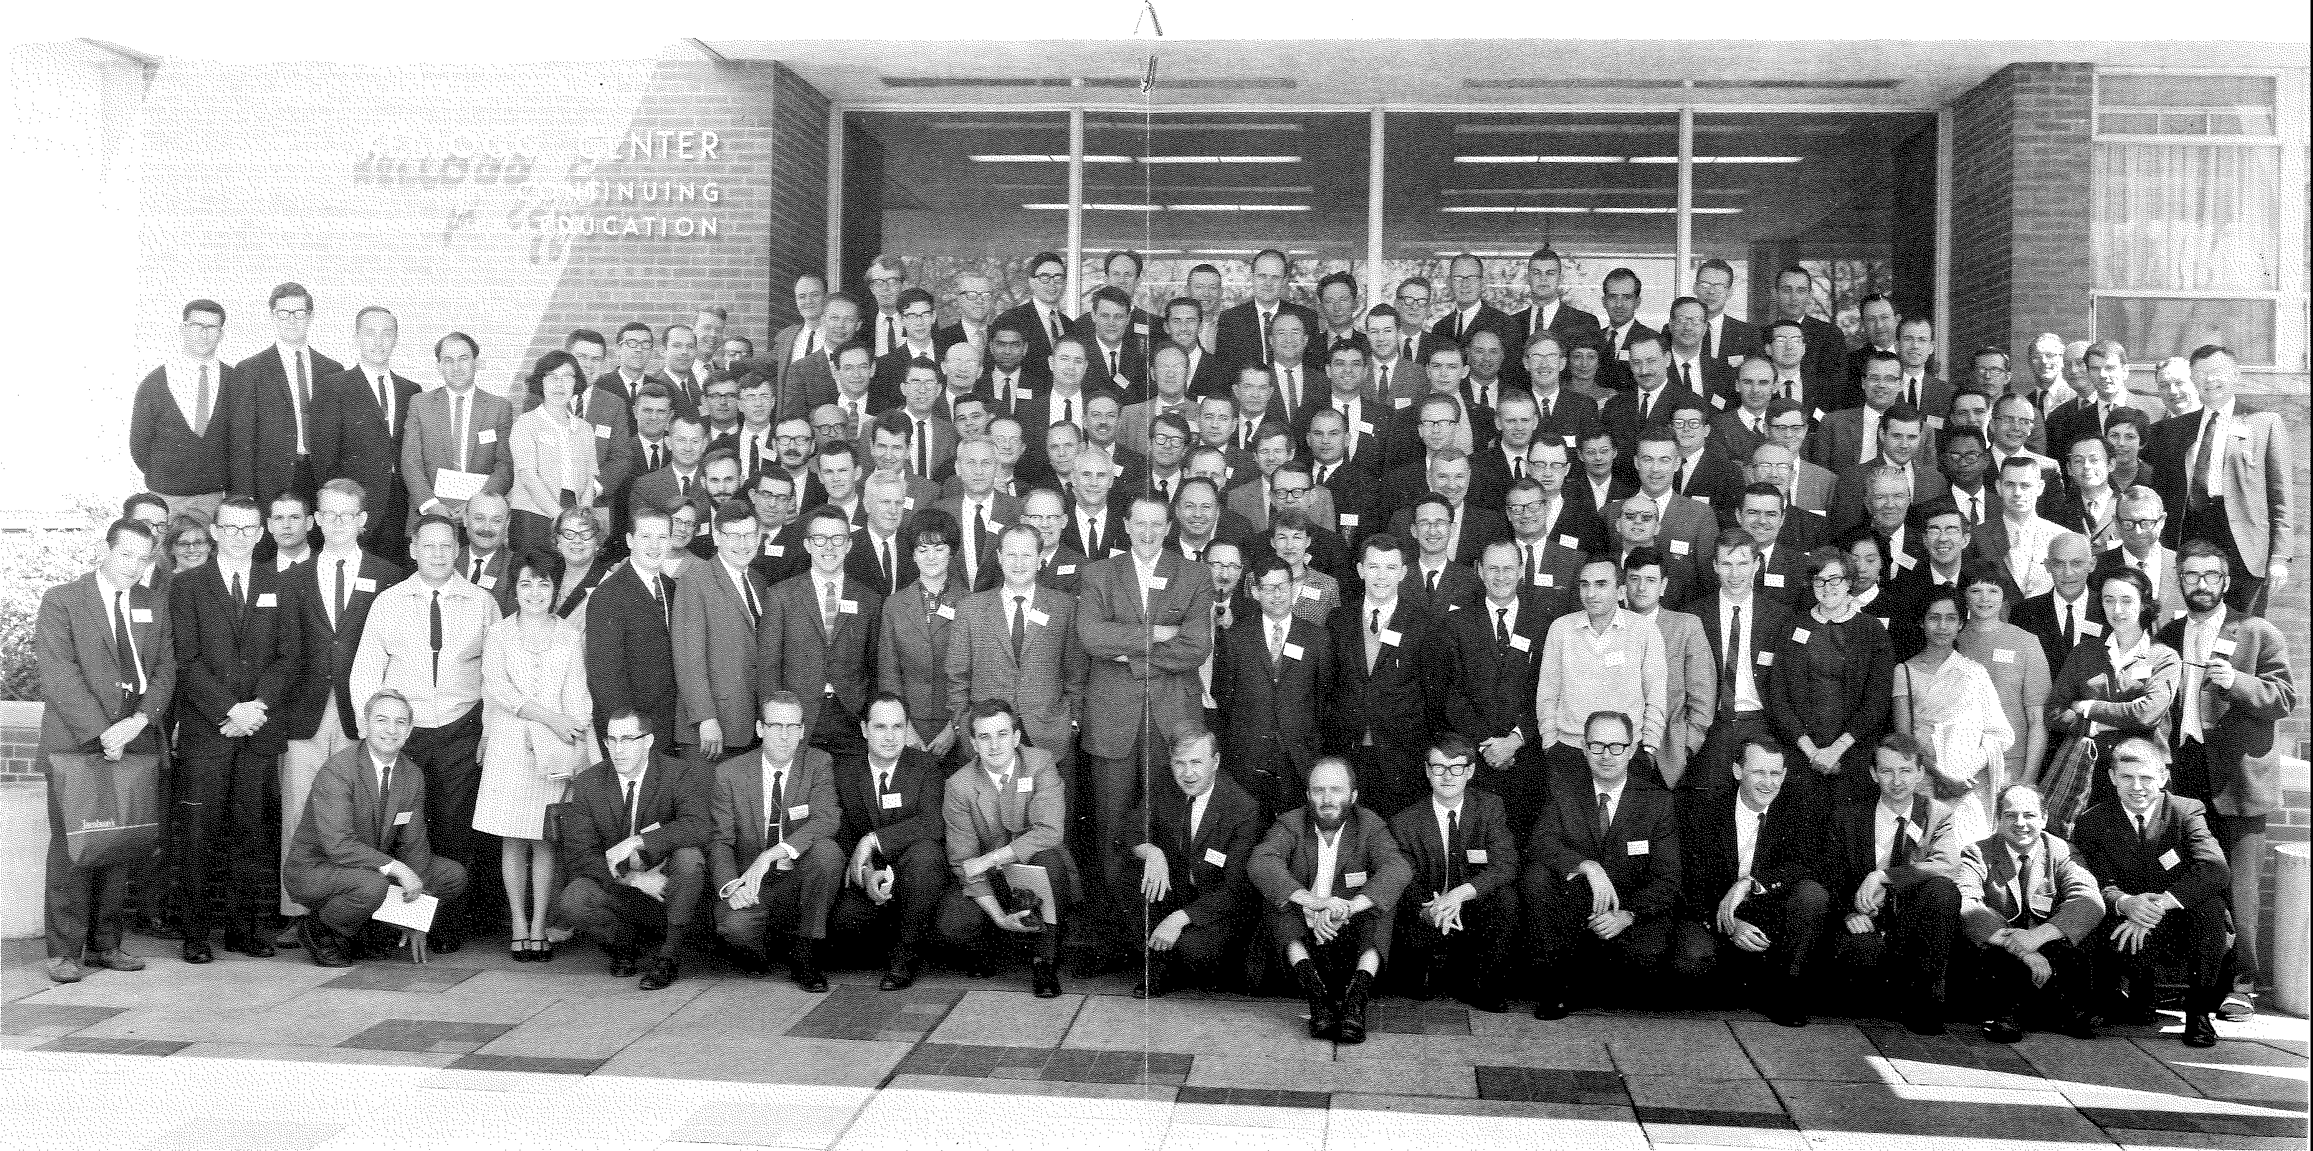

Group photograph of participants at the Dedication Symposium, May 11, 1967. The conference was attended by approximately 130 scientists from different institutions through-

out the nation, about 100 participants from MSU, and the staff of the PAL, which included at that time 10 faculty members, 22 research associates, and 16 graduate students.

new building. After the contract had been awarded and before a Director was in place, Dean Byerrum and Professors Robert Bandurski (Department of Botany and Plant Pathology) and Edward Tolbert (Department of Biochemistry) devoted a great amount of time and effort to getting the project off the ground. Both helped Lloyd Wilson tremendously, Bandurski particularly in selecting and obtaining supplies and equipment, and Tolbert in supervising the construction of the building. Lloyd Wilson, who continued as a devoted, hard-working Assistant to the Director throughout the developmental phase of the Laboratory, was also instrumental in establishing excellent relations with the various administrative and supportive units at MSU. Lloyd retired in September 1, 1985, but the PRL continues to benefit from his services to this day.

The administration of the contract was in the hands of Howard Grider (MSU's Contracts Office) and Fred Mattmueller (AEC's Chicago Operations Office). Their cooperative attitude and flexibility were a great help.

On the AEC side, the project was conceived by the Director of the Division of Biology and Medicine, the late Charles Dunham, and his Deputy Director, James Liverman. Richard Caldecott was specially appointed to evaluate, with assistance of Robert Reitemeier, the various proposals. After the PRL was established, several members of the Division's staff supervised its affairs: George Duda, Charles Edington, John Kirby-Smith, John Totter, George Stapleton and, last but not least, Robert Rabson who, presently in his capacity as Director of the Department of Energy's Division of Energy Biosciences, remains our immediate "boss" at Washington.

The AEC was replaced, in 1975, by the broader-based Energy Research and Development Administration (ERDA), and this, in turn, by the Department of Energy in 1978. The name of the Laboratory changed each time, too, from MSU-AEC to MSU-ERDA to MSU-DOE Plant Research Laboratory. These changes broadened the Laboratory's mandate to look at basic plant processes, especially with regard to the growth of plants as a renewable resource.

**The Continuation Hans Kende**

Anton Lang retired from the directorship of the PRL on June 30, 1978, but remained

a regular faculty member of the Laboratory and of the Department of Botany and Plant Pathology until his mandatory retirement five years later. Since no replacement was on board, I became Acting Director of the PRL. The transfer of responsibilities was accomplished smoothly and unceremoniously. On July 1, Anton appeared in my office and

handed me a pile of papers pertaining to ongoing business. From then on, he completely removed himself from the administration of the Laboratory. He generously offered advice when asked but he never tried to influence administrative decisions of his successors. The main activity during my year as Acting Director was the search for a permanent Director. Unfortunately, it was unsuccessful. Nevertheless, we managed to add one more faculty member to our staff, **Andrew** Hanson, who had originally come from the University of Marseille to my laboratory as a research associate. Later, he was appointed as research specialist charged to develop a research program with immediate relevance to some agricultural problem. He chose to work on biochemical adaptations that increase drought resistance of plants. In 1979, the University agreed to appoint Andrew as Assistant Professor within the tenure system and with affiliation to the Department of Crop and Soil Sciences. In July, 1979, I went on sabbatical leave and was replaced by Phil Filner as Acting Director. During his tenure, our efforts to find a permanent Director finally succeeded. **Charles Arntzen** was recruited from the University of Illinois and assumed his duties on July 1, 1980.

After two years during which the Laboratory was essentially in a holding pattern, Charles' arrival set into motion a flurry of new activities. First, he brought along a new active group of people and a new major field of research, photosynthesis. Second, his arrival coincided with that of plant molecular biology. Fittingly, the three faculty appointments during Charlie's tenure were all in that field: **Barry Chelm** (Assistant Professor of Microbiology) came in 1981 from the University of California at San Diego and established a research program in nitrogen fixation; **Lee McIntosh** (Assistant Professor of Biochemistry) joined us the same year from Harvard University to work on molecular biological aspects of photosynthesis; **Chris Somerville** (Associate Professor of Botany) was recruited jointly with the Department of Botany and Plant Pathology from the University of Alberta in 1982 to continue his studies on the molecular biology of photorespiration. Both Lee and Chris subsequently widened the scopes of their programs, Lee starting one on the alternative oxidase system and Chris on lipid metabolism. In both instances, molecular biological aspects were based on strong biochemical foundations. Unfortunately, Charlie's tenure at the PRL came to an abrupt end when he left in 1984 to take up a position with the DuPont Company. However, by moving the PRL into the new area of molecular biology and by adding three outstanding new faculty members to our group, he left a lasting mark on the Laboratory.

In the wake of Charlie's unexpected departure, I was again asked to serve as Acting Director while a search for a permanent director was conducted. When this search proved unsuccessful, I assumed the directorship of the Laboratory. The challenges and opportunities (as administrators like to phrase it) were great at that time. A new wing was added to our building for which I had to assume local responsibility. We received in the

bargain four new laboratories, an enlarged library, a room full of new growth chambers, and a graphics and photography facility. Even better, we were given the go-ahead to hire four new faculty members to inhabit the new laboratories. Together with the Department of Botany and Plant Pathology, we were able to offer an Assistant Professorship within the tenure system to **Shauna Somerville** who until then had held a research position in the PAL. Shauna established our monoclonal antibody facility and started a new "task" on plant­ pathogen interactions. In the first round of our external searching, we selected from over 200 applicants **Natasha Raikhel** and **Jonathan Walton.** Natasha came in the fall of 1986 as Assistant Professor of Botany from the University of Georgia to build a program in cell biology. Jonathan joined us in the spring of 1987 as Assistant Professor of Botany and Plant Pathology. He came from the ARCO Plant Cell Research Center in Dublin, California, to establish a program on the synthesis and action of host-specific fungal toxins. **Pamela Green** and **Thomas Newman** moved from the Rockefeller University to the PAL in the fall of 1988, Pam as Assistant Professor of Biochemistry, Tom as Research Assistant Professor in the PAL. Pam's research program deals with the molecular determinants of mRNA turnover and Tom is in the process of establishing a program on the molecular events underlying gravitropic responses in plants.

Unfortunately, the happy events surrounding the enlargement and rejuvenation of our faculty were seriously clouded by the tragic death of Barry Chelm in September 1987. Barry died of respiratory failure on a camping trip in Wisconsin. In the six years that he had been with us as a faculty member, he had built an internationally recognized program on the molecular biology of nitrogen fixation by *Bradyrhizobium japonicum.* At the time of his death, he had a large group of graduate students and postdoctoral research associates, all of whom were able to finish their projects or to move to other laboratories.

After four years of service, I stepped down from the directorship of the PRL in the summer of 1988 to devote myself again fully to my research program. I was replaced as Director by **Peter Wolk** who is also a "charter member" of the PRL. Peter had to face very soon a situation of financial retrenchments, both within the University and at DOE. However, he managed to steer our research programs clear of major financial reductions. In spite of the financial problems, he was successful in filling, jointly with the Department of Microbiology and Public Health, Barry Chaim's former position. In the summer of this year, **Frans de Bruijn will** join us from the Max-Planck-Institute of Breeding Research in Cologne and will continue his work on nitrogen fixation.

During its 25 years of existence, the PRL has established strong traditions of striving for excellence, of a full commitment to research and education, of close cooperation between individual laboratories and scientists, of public service, and of a remarkable esprit de corps. As an example of the latter, I cannot recall an instance where a faculty member

would have missed a faculty or academic personnel meeting unless he or she was out of town. We are very much aware of the fact that the investment in us has to be reflected in an output that is greater than the sum of our individual efforts. During these 25 years, over 400 young scientists have passed through our laboratories. Many of them have since assumed Important positions in academic, governmental and private institutions. Our Impact is perhaps best expressed by one of our alumni who cannot attend the symposium but who sent us a letter of appreciation: "It was a great privilege to work in a center of excellence with Its continuous influx of new people, visiting scientists, and all the seminars from the best people around. It has had a lasting effect on my views on how science should be conducted.• We hope to have the privilege to continue our mission of research and education for many more years!

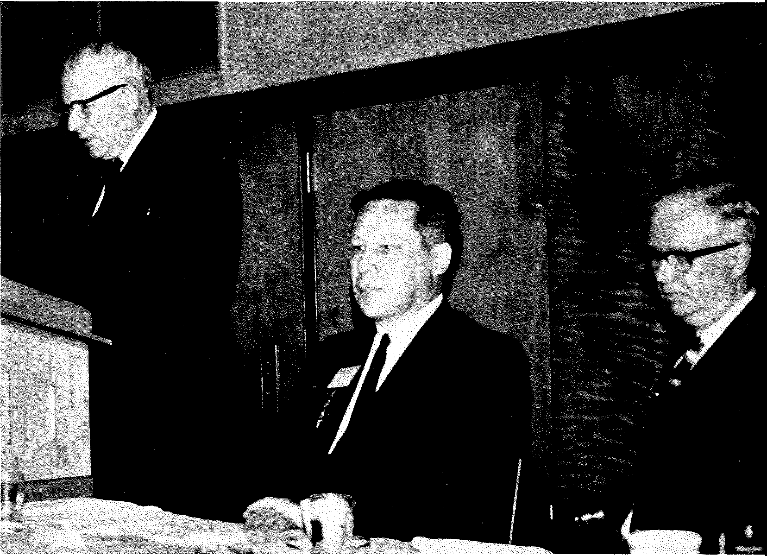

At the banquet of the Dedication Symposium. MSU President John A. Hannah (left), Anton Lang (center), and Charles Dunham, Head of Biology and Medicine, AEC (right).